
Fear of being handled vet examinations, treatments, etc.
Dogs can struggle with human interactions for many reasons. It is important that we train them to cope with intimate handling like vet examinations, grooming, giving treatments like pills etc. No dog will enjoy veterinary examinations or procedures, but we can teach him/her to tolerate it and be safe around veterinary staff. Setting your dog up for success is vital if you want him/her to be comfortable being handled. Remember at some point in your dog’s life he/she will need veterinary care, so this training is essential from an early age.
Here are some signs of a dog struggling to cope at the veterinary appointment.
Not wanting to enter the building
Excessive panting, drooling and whining
A worried look in his eye, you may be able to see more of the white of his eye than normal
Pulling on the lead
Hiding
Clinging to you – leaning on you, trying to jump up on your lap
A worried body posture like tucked tail, furled ears, worry lines on the face
Yawning a lot or licking his nose, looking away, slow eye blinking
Hyperactivity or restlessness
Snapping or growling when examined

It is important to seek professional advice when working with your dog to be comfortable with veterinary examinations. A behaviourist working in conjunction with your veterinary practice will be able to advise you on the best force free handling techniques. This is not something you should attempt to work on yourself if you don’t have training experience. However, below are a few pointers on making life easier for all and starting the process of changing your dog’s opinion of the vet.
Go to the veterinary surgery often, taking very yummy treats with you. Use food that your dog really loves, and only use this food when at the vets. Start in the car park. Drive in (you don’t even have to get your dog out of the car), and as soon as you see any small signs of worry feed your dog ten treats one after the other and then drive away. If your dog won’t eat, either your treats aren’t yummy enough or you need to go back a stage. Maybe don’t even open the car door, or park just outside the car park. Repeat this process until you can drive into the car park and your dog is relaxed or excited.

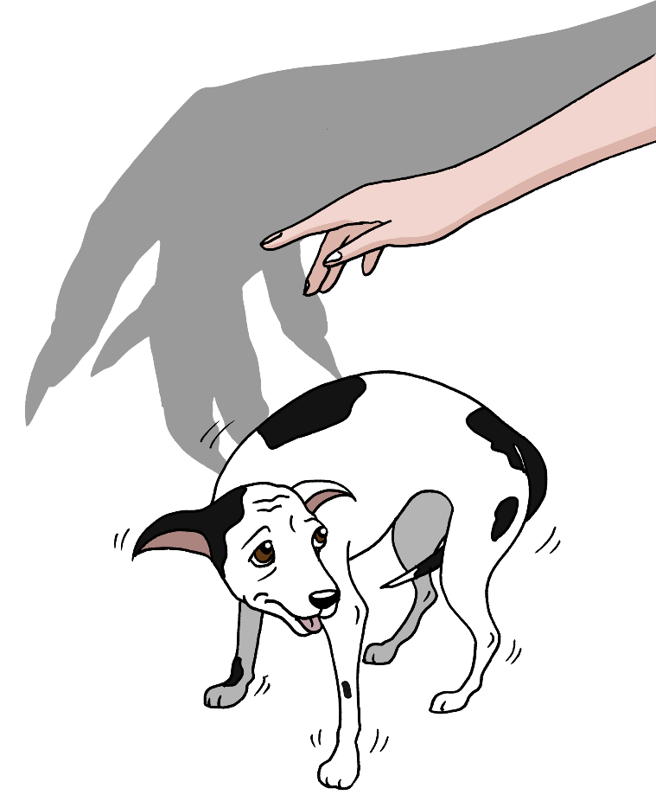

Fear of being handled
Once you can do this, take your dog out of the car and feed ten treats one after the other, get back in the car and drive away. Repeat over several sessions until happy. Then see if you can walk up to the door using the ten-treat rule, then go in the door, feed, and leave, then sit in the waiting room, feed and leave. The idea is that you break each stage down into tiny sections and for a very short time. You can build up the length of time you sit in the waiting room over several sessions. We recommend you do this when other animals may not be around at first, and then, if your dog is happy around others, when the waiting room is full.
You can then ask the staff if you can come in and sit in a consult room and feed, until your dog is comfortable. Once you are at this stage, work with a behaviourist to teach your dog to accept contact from the veterinary staff.
Other things you can do to make a trip to the vet easier for your dog are:
Take his/her bed with you into the consult room so it is something familiar.
Take a favourite toy with you.
Take a lot of very yummy soft chewy treats with you and be very generous with them at every stage of the visit.
A behaviourist will be able to show you many skills, like teaching your dog to be comfortable wearing a muzzle – a good skill for all dogs to have whether you think he/she needs one or not. Also, being restrained for blood draws, injections, and treatment administration, teaching your dog to take and hold positions that make it easier for the vet to examine certain areas of your dog’s body - the list is endless and arguably more important than learning basic obedience. It is a life skill which will ensure your dog and veterinary staff are safe and as stress free as possible in what is ultimately going to be a taxing situation for your dog.

For more information visit www.intodogs.net

