
Canine Compulsive Disorder

The term Obsessive Compulsive Disorder (OCD) is one we hear of in humans fairly frequently. People affected by this mental health condition experience frequent obsessive thoughts, causing feelings of anxiety, disgust and unease. Sufferers act out certain actions over and over again, and it’s not just humans - dogs can exhibit OCD too. Scientists mainly refer to repetitive behaviours in dogs as Canine Compulsive Disorder (CCD). Behaviours seen include:

Light chasing
Fly snapping
Tail spinning
Licking or sucking
Persistent barking
Pacing & spinning
Pica – eating inappropriate objects
Toy or object fixation
Polyphagia or polydipsia (eating or drinking obsessively)
Hallucinations (seeming to stare into space, or having bouts of sudden fearfulness with no known cause)

Whatever compulsive behaviour your dog is showing, it is distressing for all concerned and best dealt with as soon as you realise a neurotic disposition is developing. You may have to turn detective to work out why your dog is demonstrating a compulsive action. There could be any number of reasons, but once understood, there are techniques you can use to help manage and overcome the condition.
Your first task in helping your dog is to talk to your veterinary surgeon. Many health conditions cause CCD-like symptoms; focal seizures, pain issues, hypothyroidism, gut imbalances and food intolerances are just some of the reasons why dogs might display unusual behaviours.

If your dog is given a clean bill of health, then next let’s turn to psychological cause, i.e. is your dog’s emotional state the source of the compulsive behaviour? Many dogs suffer from anxiety, and numerous dogs endure boredom, spending hours alone without appropriate levels of physical or mental stimulation. Others live with conflict in their lives, forced to share their space with animals or even people who scare them. You need to check every aspect of your dog’s life and meet his or her physical, mental and emotional needs in order to start changing the behaviour.
Neurological problems in the brain, and genetics can also be a factor if no emotional or physical cause can be found and your dog lives a full and content life, but these are rarer than you may think.

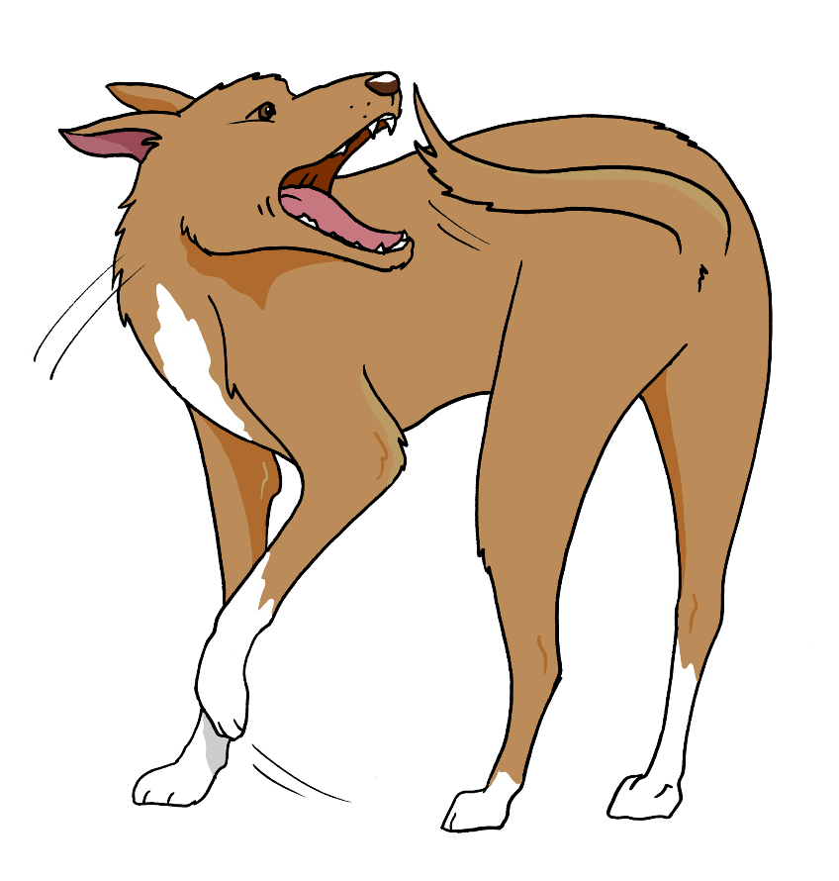

Canine Compulsive Disorder

Once you pinpoint the root cause, you can start to plan for change. There are many management tools you can utilise while you work through a behaviour programme, and a number of positive training methods you can make use of; these include Tellington TTouch Training to reduce stress and seeking the help of a behaviourist. Also talk to your vet, there are veterinary drugs which can be prescribed but research has shown that behaviour programmes are still needed to bring about change. The use of the drug alone will not cure the problem.

You will need to look at:

Exercise levels – does this need to increase or decrease?
Management tools and equipment– do you need to use a crate, for example to limit your dog shadow-chasing when you aren’t around to distract him?
Environmental changes – do you need to change something at home to limit the trigger of your dog’s compulsive behaviour?
Enrichment – is your dog bored and needs more mental as well as physical exercise?
The human factor – does your dog do this behaviour because of something you are doing?
Stress – do you need to change something that your dog finds stressful and triggers his/her compulsive behaviour?
Behaviour and training – can you work with a behaviourist to put a plan for change in to place?

You will need to look at all these areas to bring about change. The book HELP! My Dog has a Canine Compulsive Disorder by Toni Shelbourne is packed full of tips and tools. This, along with professional help, may be the difference for you and your dog between heartbreak and tragedy or living a normal, stress-free life.

For more information visit www.intodogs.net

