
Fear of being left alone
Fear of being alone is fairly common in dogs; this can be attributed to them being social beings, like ourselves. A dog may be hyper-attached to one person and pine when that person is absent, or just might not cope with a lack of company, whether human or canine.
Common symptoms of separation anxiety are:
Barking or whining.
Destructive behaviour.
Urinating and defecating.
Pacing or running around the house.
Unable to eat when the owner leaves.
Clingy behaviour whilst the owner is present, like constantly following you around.
Looking anxious when you are getting ready to leave or trying to get out of the door with you.
Over the top greeting when you return.

This problem is distressing for both your dog and you as an owner, and there is no quick fix. You can help your dog get over the problem, but it will take time, patience, and effort. It is best to work with a trained professional to guide you through the stages of habitation.

Common mistakes people make with their separation anxiety dog:

Trying to fix the problem of toileting or destroying the house by crating the dog.
Not training their puppy to be comfortable alone from an early age.
Leaving their dog alone for longer than the dog can cope with.
Getting annoyed with their dog.
Trying to let them cry it out.
Telling the dog off when they discover any mess or destruction.

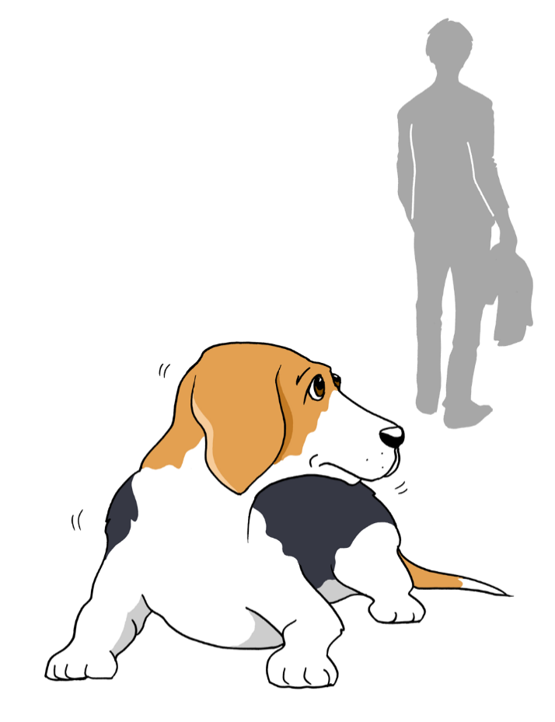

Fear of being left alone

The first step to take for anyone owning a dog who is not comfortable being left, is to make a contract with their pet never to leave him/her longer than they can cope with. This means finding friends, family, neighbours, or professionals who can mind your dog while you have to be out. Any training you may have done with your dog to be confident alone will be set back if this rule isn’t followed, so do whatever it takes to ensure this number one rule is adhered to.
About 80% of the work of training your dog to be relaxed when you are out will be done with you in the house before you even step out of the front door. Each dog is different, but some dogs will benefit from you:
- Teaching a down stay on a comfortable bed and increasing the time they are in a down stay and then the distance you can move away from them. Return and reward often for staying on the bed with a very tasty treat. Eventually you will aim to be out of sight for short periods while your dog stays on his/her bed. Once you can get some distance away from him/her for some time, you may want to add in a long-lasting yummy treat to encourage remaining on the bed with you out of view.
- If your dog struggles with this exercise and continues to follow you around the house, try getting up and going to the door in the room you are in and immediately returning and sitting down again. Repeat this often. Eventually your dog will stop following you, but might look up when you stand up, until in the end you can get up, touch the door, and sit back down again without your dog reacting. Once this happens, you can start going through the door and returning immediately, lengthening your absence gradually over time.
- Some dogs are better left in a portion of the house, rather than having the run of the whole house. Set up an area for your dog with their bed, water, toys, treats etc. Every time they go to this area, or you put them in it, give him/her some long-lasting fun things to do. You should make sure they love to go to this place and also observe him/her closely to ensure that once the yummy stuff is finished, he/she can settle calmly. If not, return soon after, before distress sets in. You should work to have your dog happy alone with you in another part of the house for at least 30 minutes before you move on to the next stage of actually leaving the house.

- While getting your dog comfortable enough to not follow you around the house, work to desensitise clues to you leaving. Put on your shoes, but don’t leave the house, pick up and put down your bag and keys, go to the front door, open, and close it but don’t go through it. Whatever you do before leaving, repeat hundreds of times without going out the door until again your dog can ignore you.
- Feeding their meals in different, non-destructible items means that you can start to use these items as you move around the home. Your dog will soon form a nice, positive association to the object which will help to calm them down as you move around. Make sure you leave the room where they are eating too, so that your dog gets used to you coming and going. If your dog struggles at this stage, make sure you stay with them and gradually build up to leaving.

Once you are at this stage, or before if you are struggling, it is worth working with a pet behaviour specialist to help you achieve the next set of goals which are, again, quite complex for some dogs. They will help you read your dog’s levels of anxiety through teaching you about dog body language, showing you how to judge how long you should be leaving your dog for and when to return, and how to build up the duration you stay out. They can also talk to you about useful equipment you might want to use.

For more information visit www.intodogs.net

